Project Design Phase-II
Data Flow Diagram & User Stories

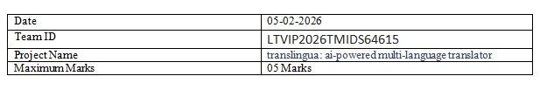
Data Flow Diagrams:
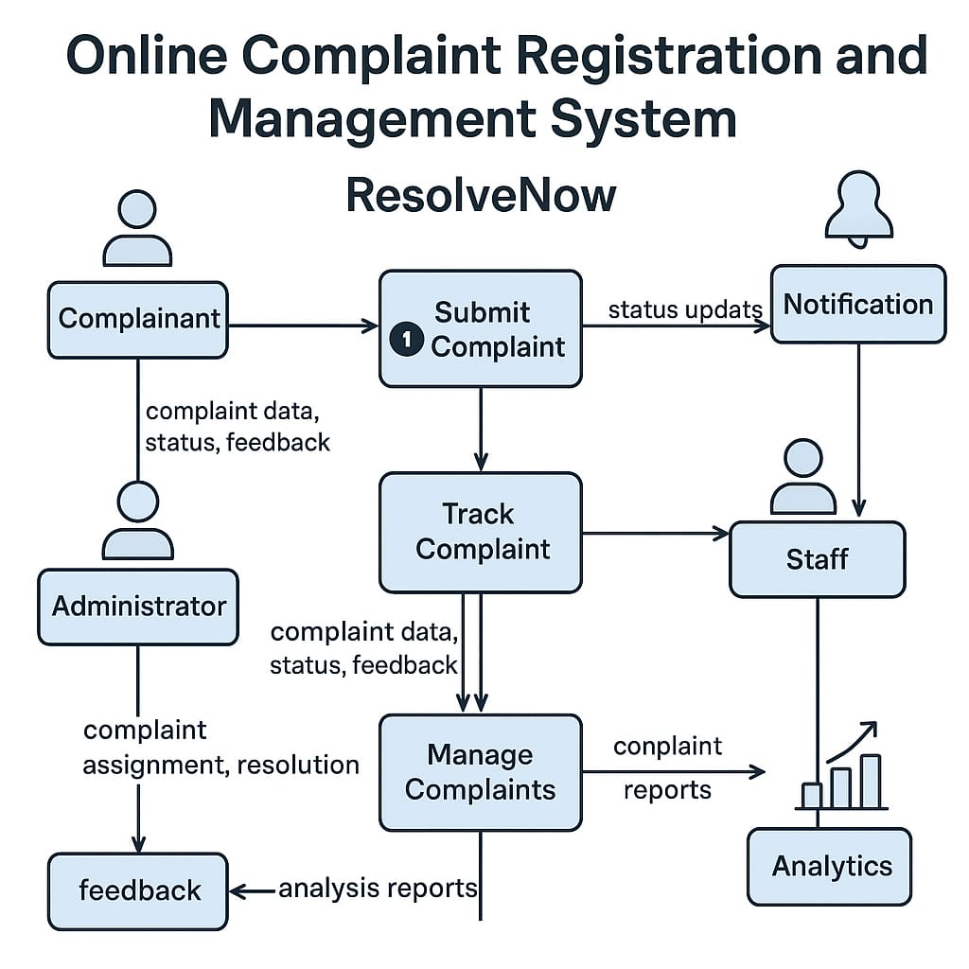
A Data Flow Diagram (DFD) illustrates how data moves within the Resolve Now platform. It captures how user interact with the system, how information flows between different components, and where the data is stored.

User Story Table – Freelance Finder
User Type | Functional Requirement (Epic) | User Story / Task | Acceptance Criteria | Priority | Release
Client |  | As a client, I can post a Complaint. | Query appears on home page of the agent. | High | Sprint-1
  Query Posting
Agent | User Query |  | Application visible to client. | High | Sprint-1
  As an Agent, I will handle the queries.
User | Messaging | As a user, I can chat with the other party in real-time. | Messages appear instantly. | Medium | Sprint-2
Client | Payment Processing | As a client, I can successfully register my complaints. | Agent will receive the queries. | High | Sprint-2
Admin | User Moderation | As an admin, I can review reported users and take action. | Reports and actions logged. | High | Sprint-1

